GAME DESIGN DOCUMENT

Youssef Iraqi

San Diego State University



**Contents**

Game Overview . . . . . . . . . . . . . . . . . . . . . . . . 3

High Concept . . . . . . . . . . . . . . . . . . . . . . . . . . 3

Unique Selling Points . . . . . . . . . . . . . . . . . . . . 3

Platform Minimum Requirements . . . . . . . . . 3

Competence Titles . . . . . . . . . . . . . . . . . . . . . . 3

Synopsis . . . . . . . . . . . . . . . . . . . . . . . . . . . . . . 4

Game Objectives . . . . . . . . . . . . . . . . . . . . . . . 4

Game Rules . . . . . . . . . . . . . . . . . . . . . . . . . . . . 4

Game Structure . . . . . . . . . . . . . . . . . . . . . . . . 4

Gameplay . . . . . . . . . . . . . . . . . . . . . . . . . . . . . 5

Game Controls . . . . . . . . . . . . . . . . . . . . . . . . . . 5

Game Camera . . . . . . . . . . . . . . . . . . . . . . . . . . . 5

Player . . . . . . . . . . . . . . . . . . . . . . . . . . . . . . . . 6

Character . . . . . . . . . . . . . . . . . . . . . . . . . . . . . . . 6

Player Metrics . . . . . . . . . . . . . . . . . . . . . . . . . . . 6

Setting . . . . . . . . . . . . . . . . . . . . . . . . . . . . . . . . 6

Audio . . . . . . . . . . . . . . . . . . . . . . . . . . . . . . . . . 6

Minimum Viable Product . . . . . . . . . . . . . . . . 7

Wishlist . . . . . . . . . . . . . . . . . . . . . . . . . . . . . . . 7

Game

Development Team

PRODUCER

Youssef Iraqi

PRODUCTION MANAGER

Youssef Iraqi

PRODUCTION COORDINATOR

Youssef Iraqi

GAME DESIGNER

Youssef Iraqi

SYSTEMS/IT COORDINATOR

Youssef Iraqi

PROGRAMMER

Youssef Iraqi

TECHNICAL ARTIST

Youssef Iraqi

Game Overview

**Title:** The Jumping Thing  
**Platform:** PC Standalone

**Genre:** Side-scrolling platform  
**Target:** Casual gamer (ages 9 - 30)

**Release date:** April, 2019  
**Publisher:** Unity Technologies

The Jumping Thing is a side-scrolling platform game where the Player is a blob of slime that must jump over obstacles in order to reach the flag at the end of the course.

High Concept

The Jumping Thing sets the Player in a large arena where he/she will encounter multiple paths to take without knowing which one will lead to the end. The Player must attempt different paths to find the final flag, all while staying on the safe blocks and avoiding all dangerous spikes.

Unique Selling Points

* Two distinct levels
* Convenient keyboard shortcuts
* Catchy background music and sound effects

Platform Minimum Requirements

PC STANDALONE

OS: Windows XP SP2+, Mac OSX 10.8+, Ubuntu 12.04+, SteamOS+

Graphics card: DX9 (shader model 2.0) capabilities; generally everything made since 2004 should work

Competence Titles

Side-scroller by Unity Technologies

Synopsis

You are a blob of slime whose only chance of survival is reaching the flag of safety at the end of the course. You must avoid sharp spikes as they will make you pop!

Game Objectives

The object of the game is to reach the end of the course without getting punctured by sharp spikes.

Game Rules

*Spike*

*Safe block*

The game level is a closed environment where the Player may only touch the safe blocks in order to reach the end of the course. The Player can move left or right and may jump up or fall down. The Player has an indefinite amount of time to complete the course but must restart from the beginning if he/she comes into contact with a spike.

Game Structure

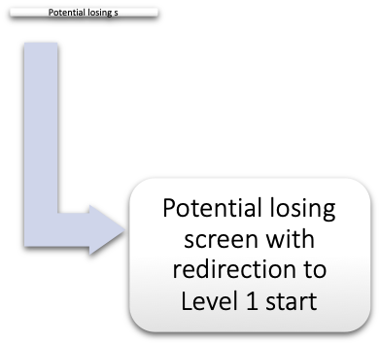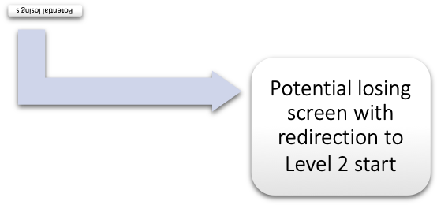

Gameplay

Game Controls (PC)

Jump

Move right

Move left

Quit

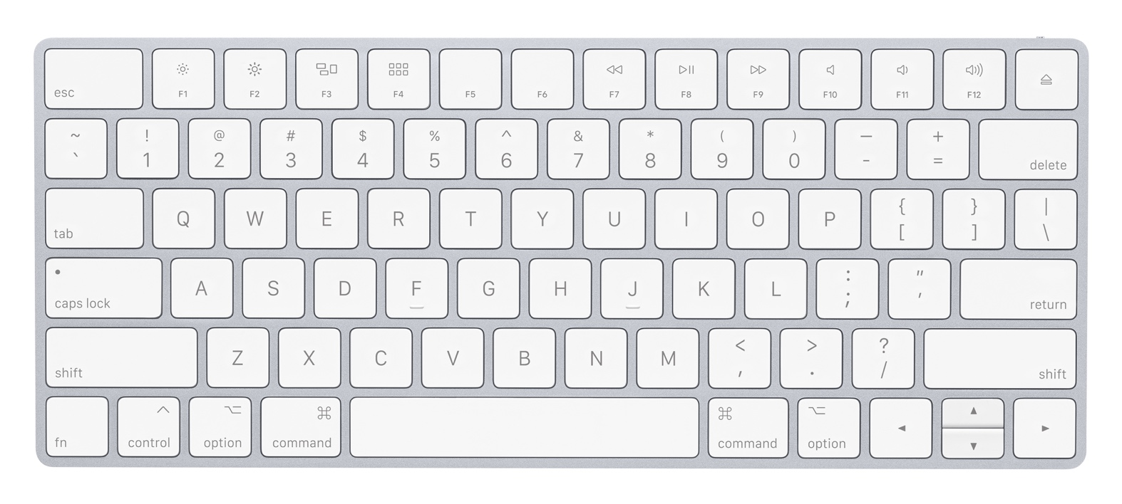

Game Camera

When the game starts, the camera will focus on the Player. The camera will follow the Player as he/she moves left and right.

The camera will remain stable vertically until the Player reaches a high enough altitude. Once this altitude is reached, the camera will shift to the upper half of the arena. The camera will shift back down to the lower half of the arena if the Player falls below that same altitude.

Player

Character

The blob of slime is an excellent jumper. It can move swiftly in both directions. However, it is not very resilient and will pop upon contact with a single spike.

Player Metrics

**Speed:** 0.1  
**Gravity:** 1.0

**Jump height:** 0.75

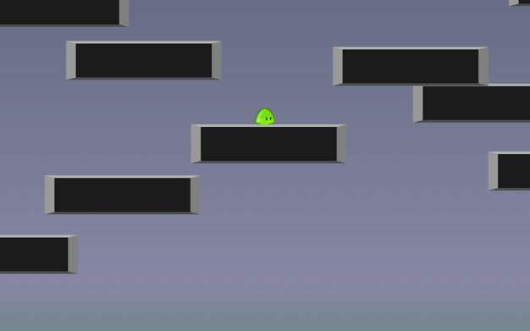Setting

The game takes place in an arena of floating blocks. Because the blob of slime is so small, the blocks appear to be very large and the camera will not be able to show the entire map. The Player will be faced with multiple potential paths to take without knowing which one will lead to the ending flag.

Audio

|  |  |  |
| --- | --- | --- |
| NAME | CATEGORY | DESCRIPTION |
| gameSong | Background music | Plays during the game |
| jump | FX | Slime jump |
| death | FX | Slime death |
| winningSong | Background music | Plays once the Player beats the game |

Minimum Viable Product

* Two full levels
* Built for the PC platform

Wishlist

ADD MORE LEVELS

Incorporate more levels into the game.

ADD DIFFERENT OBSTACLES

Create obstacles other than the spike. The obstacles could vary in shape, size, ability to move, and ability to shoot objects at the player.

ADD ATTEMPT COUNTER

Add an HUD that shows the Player what attempt number they are currently playing on.